Phase Diagrams
Callister and Rethwisch, Materials Science and Engineering, An Introduction, 9e, 2013, Wiley

Pb-Sn Phase Diagram

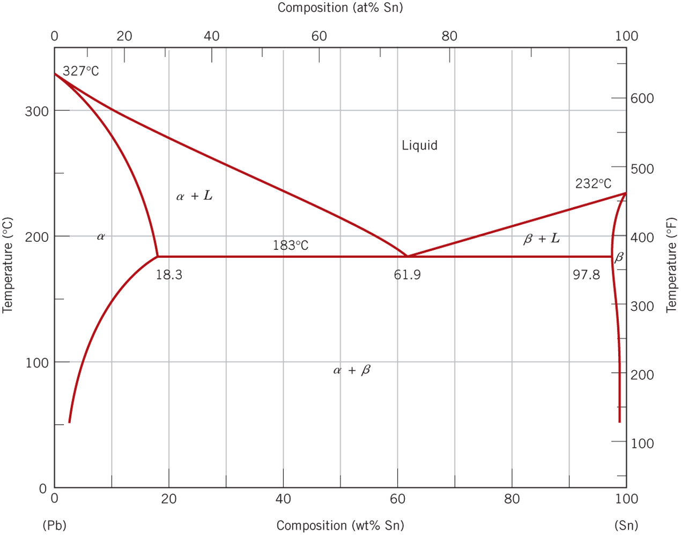

Cu-Ag Phase Diagram

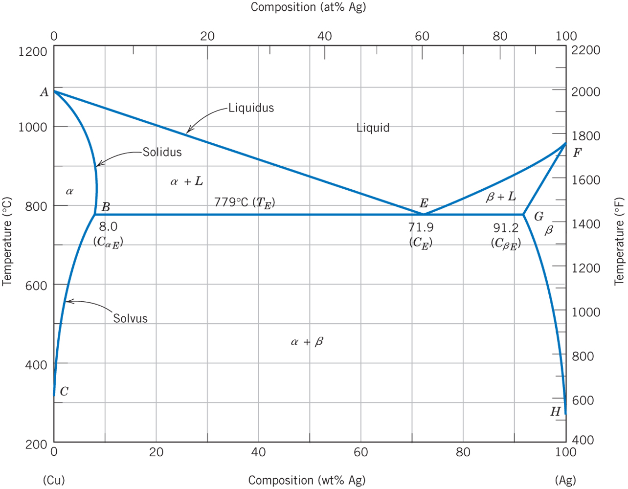

Mg-Pb Phase Diagram

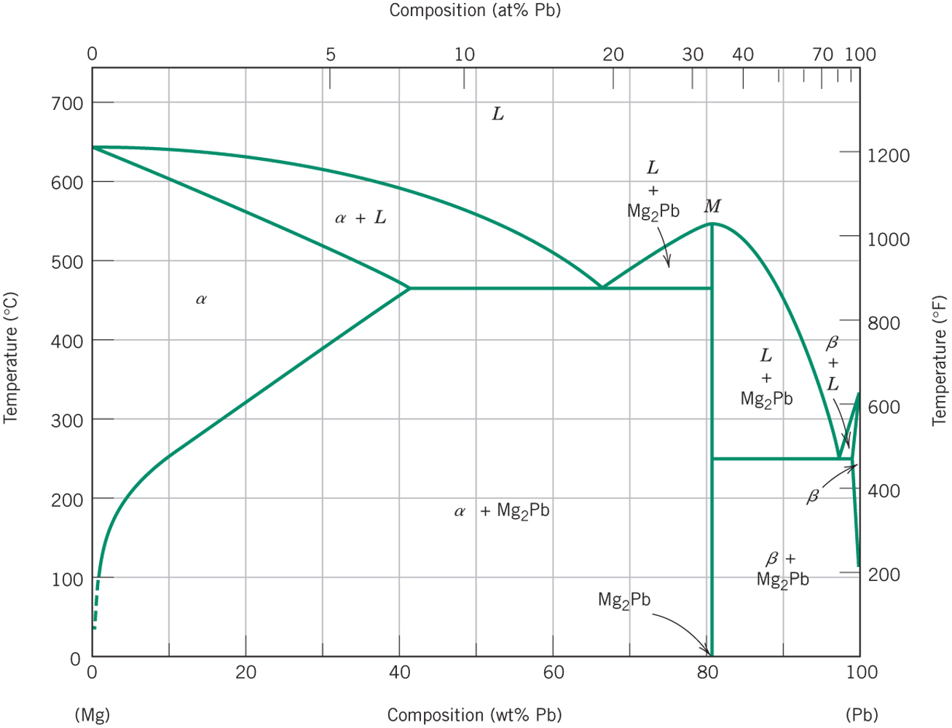

Cu-Zn Phase Diagram

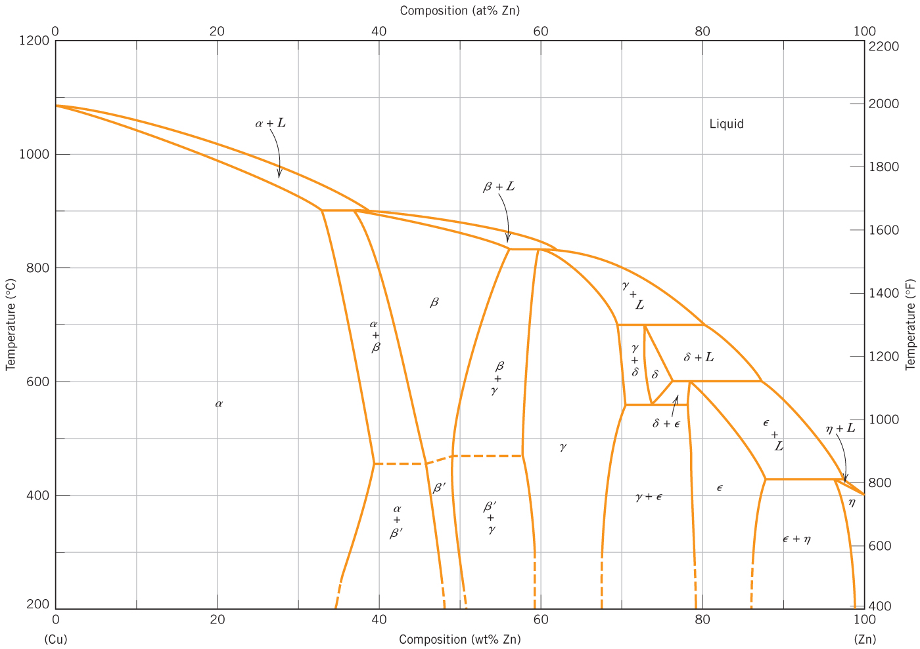

Fe-C Phase Diagram

