3/177 Ans: $\left|∆E\right|=13.470 J; n=99.8\%$

A 75-g projectile traveling at 600 m/s strikes and becomes embedded in the 40-kg block, which is initialy stationary. Compute the energy lost during the impact. Express your answer as an absolute value |ΔE| and as a percentage n of the orginal system energy E.

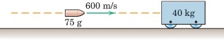

3/188 Ans: $v=13.83 mi/hr, θ=83.9° west of north$

Car A weighing 3200 lb and traveling north at 20 mi/hr with car B weighing 3600 lb and traveling at 30 mi/hr as shown. If the two cars bcecom entangled and move together as a unit after the crash, compute the magnitude v of their common velocity immediately after the impact and the angle θ made by the velocity vector with the north direction.

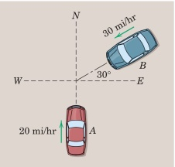

3/194 Ans: t_{s} = 3.46 s

The initially stationary 20-kg block is subjected to the time-varying horizontal force whose magnitude P is shown in the plot. Note that the force is zero for all times gerater than 3 s. Determine the time t_{s} at which the block comes to rest.

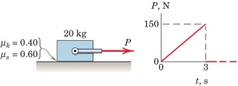

3/201 Ans: (a) 19.56 ft/sec = 13.33 mi/hr; (b) a_{A} = 97.8 ft/sec² left, a_{B} = 195.6 ft/sec² right; (c) 12,150 lb

Car B is intitially stationary and is struck by car A mvong with initial speed v₁ = 20 mi/hr. The cars become entangled and move togetehr with speed v′ after the collisions. If the time duraiton of the collison is 0.1 sec, determine (a) the common final speed v′; (b) the average acceleration of each car during the collision, and (c) the maganitude R of the average force exerted by each car on the other car during the collision.

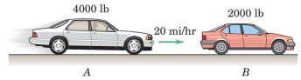

3/219 Ans: t = 15.08 s

The assembly starts from rest and reaches an angular speed of 150 rev/min under the action of a 20-N force T applied to the string for t seconds. Determine t. Negelct friction and all masses except those of the four 3-kg spheres, which may be treated as particles.

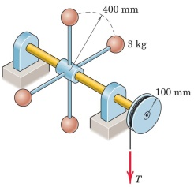

3/229 Ans: ω = 0.824(v/L)

The small spheres, which have the masses and initial velocities shown in the figure, strike and become attached to the spiked ends of the rod, which is freely pivoted at O and is initially at rest. Determine the angular velocity ω of the assembly after impact. Neglect the mass of the rod.

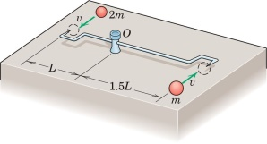

3/241 Ans: $e=0.724; n=47.6\%$

As a check of the basketball before the start of a game, the referee releases the ball from the overhead position, shown, and the ball rebounds to about waist level. Determine the coefficient of constitution e and percentage n of the original energy lost during the impact.

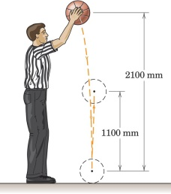

3/244 Ans: $\frac{m_{1}}{m_{2}}>\frac{1}{e}$

The sphere of mass m₁ travels with an initial velocity v₁ directed as shown and strikes the stationary sphere of mass m₂. For a given coefficient of restitution e, what condition on the mass ratio m₁/m₂ ensures that the final velocity of m₂ is greater than v₁?

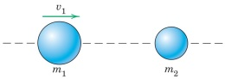

3/245 Ans: $h=g/ω^{2};T=mLω^{2}$

A tennis ball is projected toward a smooth surface with speed v as shown. Determine the rebound angle θ₁ and the final speed v′. the coefficient of resistution is 0.6.

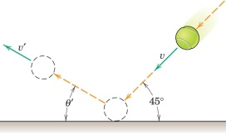

3/250 Ans: $\left(a\right)$ h = 10.94 in., (b) h₂ = 7.43 in.

If the center of the ping-pong ball is to clear the net as shown, what height h should the ball be horizontally served? Also determine h₂. The coefficient of restitution for the impacts between ball and table is e = 0.9, and the raius of the ball is r = 0.75 in.

\