3/17 (6e) $a=\frac{g}{3\sqrt{3}}$

A steel ball is suspended from the accerlating frame by two cords A and B. Determine the acceleration of the frame which will cause the tension in A to be twice that in B.

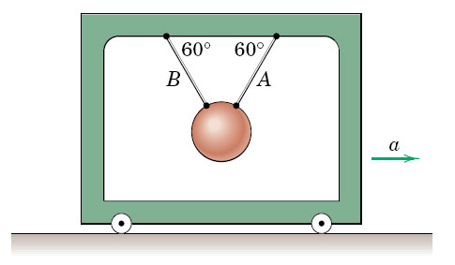

3/26 (6e)

The system is released from rest with the cable taut. Neglect the mass and friction of the pulley and calculate the acceleration of each body and the cable tension T upon release if (a) μ_{s} = 0.25 and μ_{k} = 0.20, and (b) μ_{s} = 0.15, μ_{k} = 0.10.

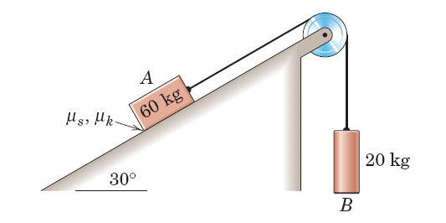

3/30 (6e)

A heavy chain with mass ρ per unit length is pulled along a horizontal surface consisting of a smooth section and a rough section by the constant force P. If the chain is initially held on the smooth surface with x = 0 and if the coefficient of kinetic friction between the chain and the rough surface is μ_{k}, determine the velocty v of the chain when x = L. Assume that the chain remains taut and thus moves as a unit throughout the motion. What is the minimum value of P that will permit the chain to remain taut. (Hint: acceleration must not become negative).

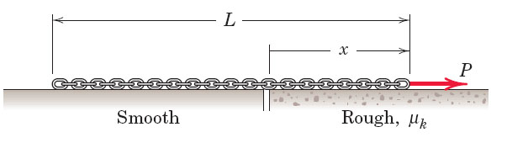

3/48 Ans: N = 9.41 N; v = 4.52 m/s

If the 2-kg block passes over the top B of the circular portion for the path with a speed of 3.5 m/s, calculate the magnitude of N_{B} of the normal force exerted by the path on the block. Determine the maximum speed v which the block can have at A without losing contact with the path.

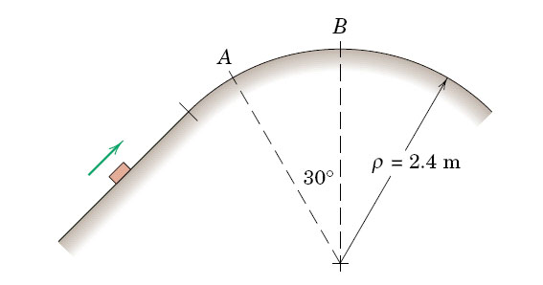

3/70 Ans: $F_{OA}=2.46 N; F_{slot}=1.231 N$

The slotted arm OA rotates about a fixed axis through O. At the instant under consideration,
$θ=30° ; \dot{θ}=45 deg/s, and \ddot{θ}=20 deg/s^{2}$. Determine the forces applied by both arm OA and the sides of the slot to the 0.2-kg slider B. Neglect all friction, and let L = 0.6 m. The motion occurs in a vertical plan.

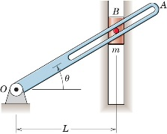

3/80 Ans: $3.41 rad/s ≤ ω≤7.21 rad/s$

A small object is placed on the inner surface of the conical dish at the radius shown. If the coefficient of static friction between the object and the conical surface is 0.30, for what range of angular velocites ω about the vertical axis will the block remain on the dish without slipping? Assume the speed changes are made slowly so that any angular acceleration may be neglected.

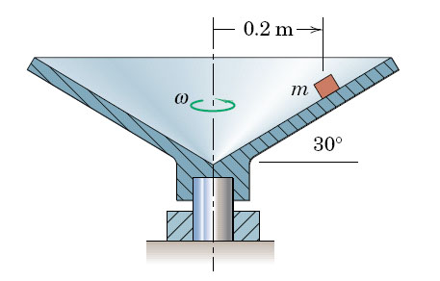

3/83 Ans: $T=2.52 lb; N=0.326 lb on side B$

The slotted arm revolves in the horizontal plane about the fixed vertical axis through Point O. The 3-lb slider C is drawn toward O at the constant rate of 2 in./sec by pulling the cord S. At the instant for which r = 9 in., the arm has a counterclockwise angular velocity ω = 6 rad/sec and is slowing down at the rate of 2 rad/sec². For this instant, determine the tension T in the cord and the magnitude N of the force exerted on the slider by the sides of the smooth radial slot. Indicate which side, A or B, of the slot contacts the slider.

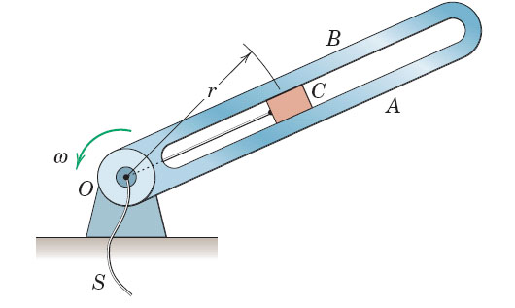

3/85 (6e) Ans: $h=g/ω^{2};T=mLω^{2}$

The small ball of mass m is attached to a light cord of length L and moves as a conical pendulum in a horizontal circle with a tangential velocity v. Locate the plane of motion by determining h, and find the tension T in the cord.

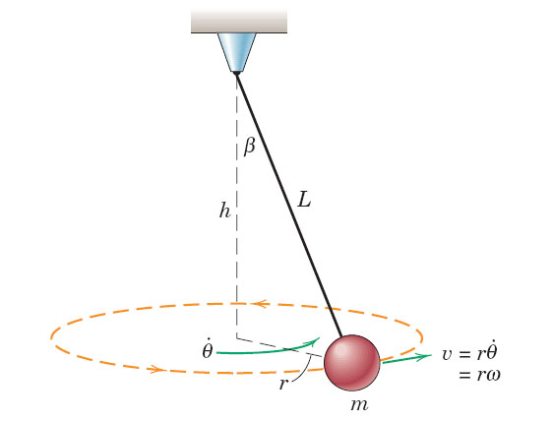

3/97 Ans: ${\left(U_{1-2}\right)}_{s}=3.38 ft–lb; {\left(U_{1-2}\right)}_{W}=-2.72 ft–lb$

The spring is unstretched at the position x = 0. Under the action of a force P, the cart moves from the initial poistion x₁ = ‒6 in. to the final position x₂ = 3 in. Determine (a) the work done on the cart by the spring and (b) the work done on the cart by its weight.

\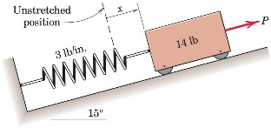

3/101 Ans: v = 2.32 m/s

The 0.5-kg collar C starts from rest at A and slides with negligible friction on the fixed rod in the vertical plane. Determine the velocity v with which the collar strikes B when acted upon by the 5-N force, which is constant in direction. Neglect the small dimensions of the collar.

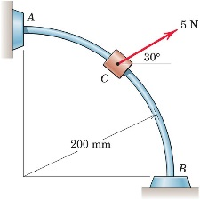

3/114 Ans: v = 1.881 m/s

The 4-kg ball and the attached light rod rotate in the vertical plane about the fixed axis at O. If the assembly is released from rest at $θ=0$, and moves under the action of the 60-N force, which is maintained normal to the rod, determine the velocity v of the ball as θ approaches 90°. Treat the ball as a particle.

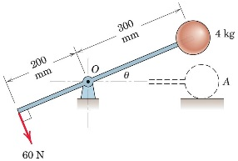

3/129 Ans: v = 53.2 m

In a railroad classification yard, a 68-Mg freight car moving at 0.5 m/s at A encounters a retarder section at B which exerts a retarding force of 32 kN on the car in the direction opposite to motion. Over what distance x should the retarder be activated in order to limit the speed of the car to 3 m/s at C.

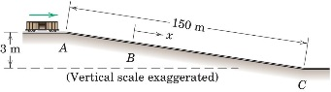

3/146 Ans: (a) k = 393 N/m; (b) v = 1.370 m/s, $\dot{θ}=2.28 rad/s$

The 0.8-kg particle is attached to the system of two light rigid bar, all of which move in a vertical plane. The spring is compressed an amount b/2 when θ = 0, and the length b = 0.30 m. The system is released from rest in a position slightly above that for θ = 0. (a) If the maximum value of θ is observed to be 50°, determine the spring constant k. (b) For k = 400 N/m, determine the speed v of the particle when θ = 25°. Also find the corresponding value of $\dot{θ}$.

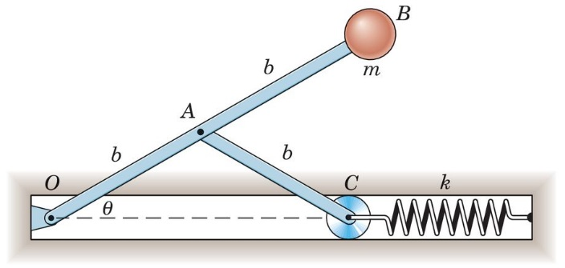

3/159 Ans: v = 2.30 m/s

The small bodies A and B each of mass m are connected and supported by the pivoted links of negligble mass. If A is released from rest in the position shown, calculate its velocity v_{A} as it crosses the vertical centerline. Neglect any friction.

